Theory:
Data quality inspection ensures that the dataset is accurate, consistent, and reliable. It involves checking for missing values, duplicate entries, and incorrect data types. Identifying such issues helps prevent errors during analysis. Missing values can be handled using imputation or removal techniques. Duplicate records can lead to biased results and must be removed. Data type inconsistencies may cause computation errors. Detecting irrelevant or redundant columns is also important. Class imbalance is analyzed for classification problems. This step ensures that data is clean and usable. It forms the foundation for effective analysis.
Dataset Description:
The dataset contains daily silver price records with no significant missing values. It includes numerical features for prices and trading volume. The Date column is unique for each record. Overall, the dataset is well-structured
Program Code:
import pandas as pd
import numpy as np

# Step 2: Load Dataset
df = pd.read_csv('silver_prices_data.csv')

print("\n===== DATASET LOADED ===音が")
print(df.head())

# --------------------------------------------
# Step 3: Initialize Report List
# --------------------------------------------
report = []

# --------------------------------------------
# Step 4: Missing Values Check
# --------------------------------------------
missing = df.isnull().sum()

for col in missing.index:
if missing[col] > 0:
report.append({
"Issue": "Missing Values",
"Column": col,
"Affected Records": missing[col],
"Suggested Action": "Use imputation (mean/median) or drop rows"
})

# --------------------------------------------
# Step 5: Duplicate Records Check
# --------------------------------------------
duplicates = df.duplicated().sum()

if duplicates > 0:
report.append({
"Issue": "Duplicate Records",
"Column": "All Columns",
"Affected Records": duplicates,
"Suggested Action": "Remove duplicates using drop_duplicates()"
})

# --------------------------------------------
# Step 6: Identifier / Irrelevant Columns
# --------------------------------------------
for col in df.columns:
unique_vals = df[col].nunique()

if unique_vals == len(df):
report.append({
"Issue": "Identifier Column",
"Column": col,
"Affected Records": unique_vals,
"Suggested Action": "Consider dropping if not useful for analysis"
})

# --------------------------------------------
# Step 7: Data Type Issues
# --------------------------------------------
for col in df.columns:
if df[col].dtype == 'object':
# Check if numeric stored as string
try:
pd.to_numeric(df[col])
report.append({
"Issue": "Inconsistent Data Type",
"Column": col,
"Affected Records": len(df),
"Suggested Action": "Convert to numeric using pd.to_numeric()"
})
except:
pass

# --------------------------------------------
# Step 8: Date Column Check
# --------------------------------------------
for col in df.columns:
if 'date' in col.lower():
try:
df[col] = pd.to_datetime(df[col])
except:
report.append({
"Issue": "Date Format Issue",
"Column": col,
"Affected Records": len(df),
"Suggested Action": "Convert using pd.to_datetime()"
})

# --------------------------------------------
# Step 9: Class Imbalance Check
# --------------------------------------------
target = "Close" # Change if needed

if target in df.columns:
if df[target].dtype == 'object':
class_counts = df[target].value_counts()
imbalance_ratio = class_counts.max() / class_counts.min()

if imbalance_ratio > 2:
report.append({
"Issue": "Class Imbalance",
"Column": target,
"Affected Records": len(df),
"Suggested Action": "Use resampling techniques (SMOTE/undersampling)"
})
else:
report.append({
"Issue": "No Class Imbalance",
"Column": target,
"Affected Records": len(df),
"Suggested Action": "Target is continuous (regression problem)"
})

# --------------------------------------------
# Step 10: Create Report DataFrame
# --------------------------------------------
report_df = pd.DataFrame(report)

print("\n===== DATA QUALITY REPORT =====")
print(report_df)

# --------------------------------------------
# Step 11: Save Report
# --------------------------------------------
report_df.to_csv("data_quality_report.csv", index=False)
print("\nReport saved as 'data_quality_report.csv'")

Stepwise output:
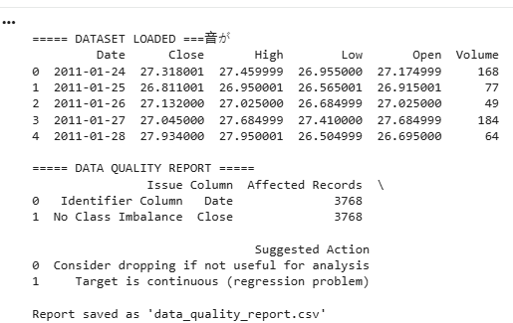
Conclusion:
The dataset shows good data quality with minimal issues. No major missing values or duplicates were found. Minor preprocessing like data type conversion may be required. The dataset is ready for further analysis.
The dataset shows good data quality with minimal issues. No major missing values or duplicates were found. Minor preprocessing like data type conversion may be required. The dataset is ready for further analysis.
analysis.

